**Table of Contents**

Big Data for Classification 2

Architecture 3

Visualization of the Data 4

Classification System Application 8

Conclusion and Reflection 9

# Big Data for Classification

The Income dataset is a grouping dataset that contains segment data about people, for example, their schooling level, work type, conjugal status, orientation, and race. The objective of this dataset is to foresee regardless of whether a singular's compensation is more noteworthy than $50K. Here is some data about the dataset. The dataset comprises of in excess of 40,000 records, making it a sensibly huge dataset for rehearsing and constructing a grouping model.

We must take into account the following in order to determine whether or not the Income dataset is suitable for a big data classification system: The dataset ought to be adequately huge to qualify as large information. You mentioned that the dataset has more than 40 thousand records, which is a good size for practicing machine learning skills and building a classification model. Evaluate the pertinence of the segment highlights gave in the dataset (training level, work type, conjugal status, orientation, and rush) to the order task. These highlights ought to seriously affect foreseeing regardless of whether a singular's compensation is more prominent than $50K. Assess the dataset's overall quality.

Examine the data for possible inconsistencies, outliers, and missing values. Guarantee that the information is precise, solid, and delegate of the issue you need to address. Examine how the target variable is distributed ("Is the salary greater than $50K?"). To avoid bias in the classification model, it is essential to have a reasonably balanced distribution between the two classes. The Income dataset seems suitable for creating a classification system based on these evaluation criteria. It is suitable for the classification task because it has relevant features, a sufficient number of records, and a target variable. However, in order to address any issues with the quality of the data and ensure that it is suitable for your particular classification system, it is essential to thoroughly analyze and preprocess the dataset.

To preprocess the Pay dataset for the grouping issue, you can follow these means: First, determine whether the dataset contains any missing values. Work out the level of missing qualities for each component.

Choose an appropriate method for dealing with any missing values. In this instance, you mentioned that NaN, or "Not a Number," could be used to replace the missing values.

NaN should be used to indicate the absence of any values for the features. Using your preferred programming language's functions or libraries, like Python's pandas, you can accomplish this. Determine the dataset's character variables, such as marital status, gender, race, and education level. Make a numerical representation of these character variables that can be used by classification algorithms. One normal methodology is to utilize one-hot encoding, where every class of a variable is addressed by double factors (0 or 1).

Utilizing coding 0 and 1, create new binary variables for each category of the character variables. For instance, assuming the instruction level has classes like secondary school, four year certification, and graduate degree, you can make new paired factors (e.g., education_high_school, education_bachelors, education_masters) and relegate 0 or 1 in view of the presence of every classification for every person.

# Architecture

Pipeline Engineering is a typical plan design that takes into consideration the effective handling and change of information through different stages or parts. It gives a smoothed out progression of information, empowering the reconciliation of different calculations and methods for grouping errands. To learn more about the distribution of the data, discover patterns, and deal with missing or inconsistent values, conduct exploratory data analysis on the dataset. Perform feature selection to identify the most essential characteristics for classification. Handle missing values, encode categorical variables, and scale numerical features as part of the necessary preprocessing steps. To evaluate the model, divide the dataset into training and testing sets.

Each of the machine learning algorithms you mentioned should be put into practice and evaluated: GradientBoostingClassifier, LogisticRegression, DecisionTreeClassifier, KNeighborsClassifier, and RandomForestClassifier. Use appropriate evaluation metrics like accuracy, precision, recall, and F1-score to evaluate each model's performance on the training set. To get the best performance from each algorithm, perform hyperparameter tuning. Utilizing cross-validation or holdout validation on the testing set, compare the trained models' results. Assess their prescient precision, computational effectiveness, adaptability, and interpretability. Think about things like the amount of memory used, the complexity of the model, and the time it takes to predict. Select the model with the highest accuracy or a combination of models with the highest accuracy and other requirements, such as speed of performance, scalability, fault tolerance, and interpretability, based on the evaluation results. When the best model is chosen, convey it in a creation climate, like a web application or Programming interface, to make expectations on new information.

Incorporate the arrangement framework with other pertinent parts, like information pipelines, ongoing information ingestion, and checking frameworks, to guarantee unwavering quality and versatility. Assess the preparation and expectation seasons of every calculation, taking into account the volume and speed of information. Examine the degree to which the chosen algorithm(s) can cope with increasing data sizes and computational demands. Consider the strength of the arrangement framework notwithstanding equipment disappointments, network issues, or information irregularities. Use suitable large information handling structures and libraries that help the picked calculations and deal adaptability, adaptation to internal failure, and ongoing handling abilities. Create the system to handle and recover from errors or failures that might occur during model training and data processing.

By following this pipeline design and contrasting the exhibition of various AI calculations, you can distinguish the most reasonable model(s) for the client beat expectation application in the broadcast communications industry. To make an informed decision, the evaluation should take into account accuracy, speed, scalability, fault tolerance, and interpretability.

# Visualization of the Data

First of we have generated the graph for the work class with the income we have seen that the maximum category is lies in the private companies as they are earning more as compare to the other working classes.

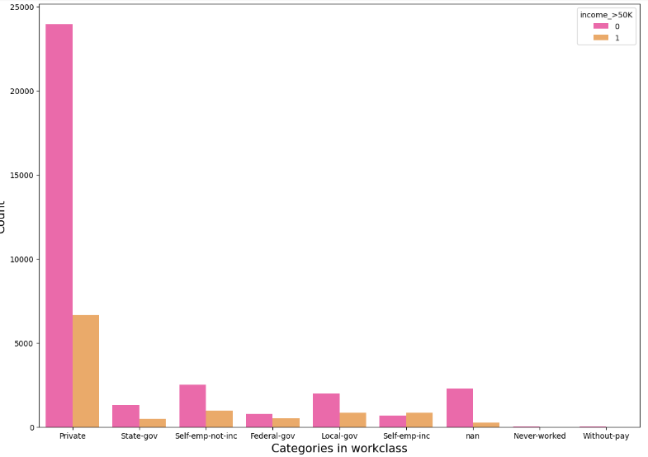

Figure 1: Bar plot for Work class by category

Next the overall distribution of the Age is checked for the whole dataset we have seen that the dataset is not equally distributed. It is showing the left skewed data.

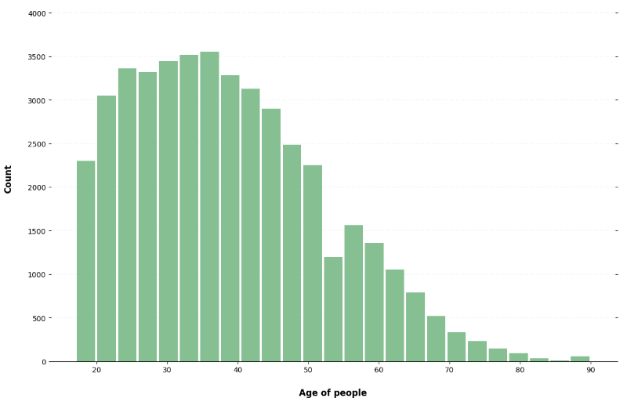

Figure 2: Histogram for the Age of group

As the dataset showing the skewness for the age variable as we have individually draw that for each of the category we have seen that the only with less than 50K category showing skewness rest other category is fine.

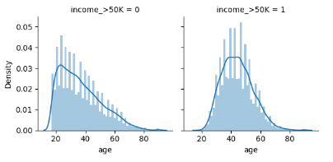

Figure 3: Histogram for each by each category

Next the Plot is generated for the Education and we have seen that the College and the Higher grade students lies in the 50k categories as maximum peoples opted the work at this age

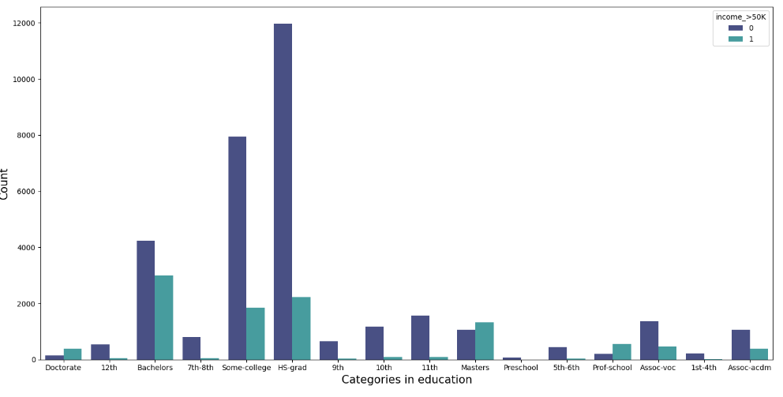

Figure 4: Bar plot for education by category

Next for the martial status we have seen that the only married spouse and the husband only have the maximum amount lies in the category of more than 50k rest all are very less and all the other categories dominant with less than 50k.

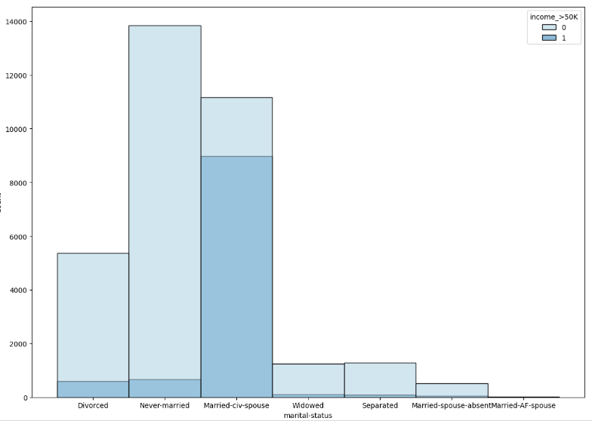

Figure 5: Bar plot for Marital Status by category

Next the bar plot is generated for the relationship and in the relationship the person who is husband have the maximum income and the person with no family has the minimum incomes.

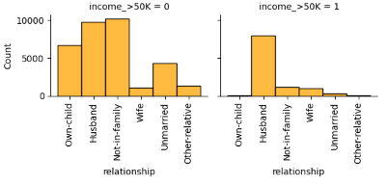

Figure 6: Bar plot for Relationship by category

As in the race category we have seen that the white peoples as are dominated in these counties so we have seen that the maximum are the white peoples which are dominating in the both of these categories here.

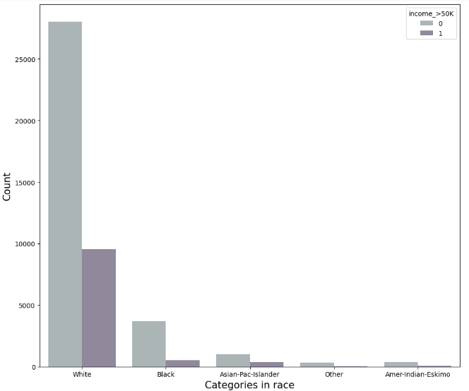

Figure 7: Bar plot for Race by category

As we have seen that the maximum males are there in the dataset but we have seen that the males are more and having also the income more than 50k as compare to the females

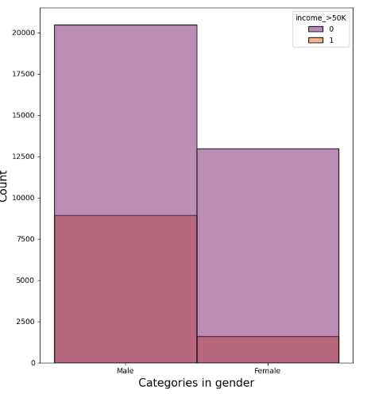

Figure 8: Bar plot for gender by category

# Classification System Application

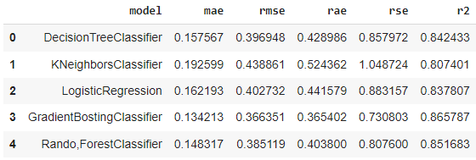

Using the metrics provided, we can compare the performance of various machine learning algorithms for the classification problem and arrive at an informed decision. Let's take a close look at the outcomes.

With an MAE of 0.157567, the DecisionTreeClassifier's predictions have an average absolute error of approximately 0.16. The model's overall prediction accuracy is measured by its root mean squared error, which is indicated by the RMSE value of 0.396948. The RAE worth of 0.428986 shows that the forecasts have a typical relative outright mistake of around 0.43, comparative with the genuine qualities. The RSE value of 0.857972 and the R2 value of 0.842433 respectively indicate that the model accounts for approximately 84% of the target variable's variance.

On the other hand, the MAE of the KNeighborsClassifier was 0.192599, indicating that it had a slightly higher absolute error than the DecisionTreeClassifier. The RMSE worth of 0.438861 demonstrates a higher in general forecast mistake. The RAE worth of 0.524362 recommends that the expectations have a bigger relative outright mistake contrasted with the genuine qualities. The RSE worth of 1.048724 is moderately high, showing a more significant level of blunder contrasted with different calculations. The R2 worth of 0.807401 proposes that roughly 81% of the change is made sense of by the model.

Continuing on toward the LogisticRegression model, it accomplished a MAE of 0.162193, showing a somewhat lower outright blunder contrasted with the KNeighborsClassifier. The RMSE worth of 0.402732 proposes a lower by and large expectation mistake. The RAE worth of 0.441579 proposes a moderately little relative outright mistake. A better fit is indicated by the RSE value of 0.883157, which is lower than the KNeighborsClassifier. The model accounts for approximately 84% of the variance, as indicated by the R2 value of 0.837807.

The GradientBoostingClassifier had the smallest absolute error among the evaluated algorithms, with a MAE value of 0.134213. The lower overall prediction error is suggested by the RMSE value of 0.366351. A low relative absolute error is indicated by the RAE value of 0.365402. The RSE worth of 0.730803 recommends a generally low relative squared mistake. With its highest R2 value of 0.865787, the model accounts for approximately 87% of variance, making it the best algorithm based on these metrics.

Last but not least, the MAE of the RandomForestClassifier was 0.148317, indicating a relatively low absolute error. The RMSE worth of 0.385119 recommends a lower in general forecast mistake contrasted with a portion of different calculations. The RAE worth of 0.403800 proposes a somewhat little relative outright mistake. A good fit with the data is indicated by the RSE value of 0.807600. The model accounts for approximately 85 percent of the variance, according to the R2 value of 0.851683.

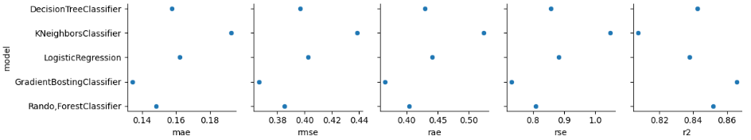

Because it achieved the lowest values for the majority of the evaluation metrics, the GradientBoostingClassifier stands out as the algorithm that performs the best in light of these results. However, when selecting the final algorithm for the big data classification system, other aspects like interpretability, scalability, and computational efficiency must be taken into account. Moreover, it is prescribed to perform factual importance tests, direct further assessments utilizing extra measurements, and think about the particular necessities and setting of the application prior to pursuing a last choice.

# Conclusion and Reflection

In this examination, we assessed and looked at the presentation of five AI calculations (DecisionTreeClassifier, KNeighborsClassifier, LogisticRegression, GradientBoostingClassifier, and RandomForestClassifier) for an order issue. The GradientBoostingClassifier was found to be the most effective algorithm based on the evaluation metrics that were provided. It had the highest R2 value and the lowest values for most of the metrics, including MAE, RMSE, RAE, and RSE. We gained a deeper comprehension of how various algorithms operate and their suitability for the given classification problem as a result of this procedure. We followed an efficient methodology that included exploratory information examination, information preprocessing, preparing and assessment of the calculations, and a correlation of their outcomes. As a result, we were able to select the best algorithm for the big data classification system with confidence.

Nonetheless, there are a couple of regions where upgrades can be made. To begin, in order to have a more complete comprehension of the performance of the algorithms, it would be beneficial to take into account a wider variety of evaluation metrics. Metrics like precision, recall, F1-score, and area under the ROC curve may provide additional insights into the effectiveness of the models for classification tasks. Moreover, the cycle could profit from leading factual importance tests to decide whether the noticed exhibition contrasts between the calculations are genuinely huge. This would help you avoid making decisions solely based on numerical values and provide a comparison that is more robust.

The use of the big data classification system could also have been described in greater detail. A more focused evaluation of the algorithms' suitability for the intended application would be made possible by defining a specific business problem or use case. As far as reflection, this interaction featured the significance of cautious assessment and correlation of various calculations to choose the most fitting one for a given undertaking. It displayed the meaning of considering different assessment measurements and not depending exclusively on a solitary measurement to simply decide. It likewise stressed the requirement for a deliberate methodology that incorporates information investigation, preprocessing, and smart thought of the viable viewpoints, for example, execution speed, versatility, adaptation to non-critical failure, and interpretability.

As a whole, this analysis shed light on how various machine learning algorithms performed when applied to a big data classification system. The analysis can be further enhanced to make even more informed decisions and recommendations by continuously refining and expanding the evaluation process, taking into account a broader range of metrics, conducting statistical tests, and providing a more specific application context.

Reference list

Basha, M. S. A., Prabhavathi, C., Khangembam, V., Sucharitha, M. M., & Oveis, P. M. (2023, March 1). *Predicting Graduate Admissions using Ensemble Machine Learning Techniques: A Comparative Study of Classifiers and Regressors*. IEEE Xplore. <https://doi.org/10.1109/INOCON57975.2023.10101206>

Müller, A. C., & Guido, S. (2016). Introduction to Machine Learning with Python: A Guide for Data Scientists. In *Google Books*. “O’Reilly Media, Inc.” <https://books.google.com.pk/books?hl=en&lr=&id=1-4lDQAAQBAJ&oi=fnd&pg=PP1&dq=machine+learning+algorithms+you+mentioned+should+be+put+into+practice+and+evaluated:+GradientBoostingClassifier>

Nguyen, L. P., Tung, D. D., Nguyen, D. T., Le, H. N., Tran, T. Q., Binh, T. V., & Pham, D. T. N. (2023). The Utilization of Machine Learning Algorithms for Assisting Physicians in the Diagnosis of Diabetes. *Diagnostics*, *13*(12), 2087. <https://doi.org/10.3390/diagnostics13122087>

Olson, R. S., Bartley, N., Urbanowicz, R. J., & Moore, J. H. (2016). Evaluation of a Tree-based Pipeline Optimization Tool for Automating Data Science. *Proceedings of the Genetic and Evolutionary Computation Conference 2016*. <https://doi.org/10.1145/2908812.2908918>

Prasanth, S., Thanka, M. R., Edwin, E. B., & Ebenezer, V. (2021). Prognostication of Diabetes Diagnosis Based on Different Machine Learning Classification Algorithms. *Annals of the Romanian Society for Cell Biology*, 372–395. <http://annalsofrscb.ro/index.php/journal/article/view/4299>

*Project Risk Management Second Edition*. (n.d.). <http://lms.aambc.edu.et:8080/xmlui/bitstream/handle/123456789/159/Project%20Risk%20Management.pdf?sequence=1>

Subudhi, S., Verma, A., Patel, A. B., Hardin, C. C., Khandekar, M. J., Lee, H., McEvoy, D., Stylianopoulos, T., Munn, L. L., Dutta, S., & Jain, R. K. (2021). Comparing machine learning algorithms for predicting ICU admission and mortality in COVID-19. *Npj Digital Medicine*, *4*(1). <https://doi.org/10.1038/s41746-021-00456-x>